**My name is Tuan Luong (Student Number s3652729). I am a curious, enthusiastic and passionate person who loves technological things and how they work around me. I am from a Vietnamese background and born overseas before coming to Australia in 2002 and getting my Australian citizenship in 2006. My hobbies are anything to do with underwater stuff including swimming and diving. I am also a fit and active person who loves to ride my bike a lot and go to the gym to get those large muscles. I’ve gained an interest in IT after 3 years of studying healthcare in which I’ve found my passion for technological things and I’ve always had a strong interest in computers ever since I was small. Within IT my interest is software engineering, programming, and network engineering. I’ve had very little IT background, but I have fixed several computer issues around RMIT during my time in Laboratory Medicine, including issues in lecture theatres.**

**My Meyers Briggs test results show that I am extroverted, intuitive, thinking and judging. These skills are critical in the role of the team leader which requires high level of judgement, extroversion with critical thinking when delegating tasks and ensuring that people stay on top of things during a team project. Furthermore I have strong auditory and listening skills as shown in my test results for my learning style in which I am able to listen to people carefully and understand them and I can visualise a project on how it would look like.**

**For my ideal job it would be in the desktop support/helpdesk or technical support roles because I enjoy the engagement and interaction with customers with the joy of helping others from my time in healthcare studies. This role requires me to work with a diverse range of customers in businesses and to have critical thinking combined with problem solving skills combined with excellent communication skills in a team-based environment. Besides the soft skills, I also require technical skills which I will acquire during my degree and throughout my career as an IT professional.**

**Industry Data**

**According to my role of technical/desktop support the skills that are in demand according to the burning glass data. The burning glass data shows that the IT skills of technical support and customer service are high in demand at the moment with 1830 openings for technical support and 1411 openings for customer service. The technical support role ranks 11th in demand according to burning glass data. The three top IT skills that are not in my required skillset is Java, javascript and SQL. The role of system administrator which involves similar tasks in technical support and customer service has around 681 openings according to the burning glass data with it being eighth highest position in demand in the top IT job titles. This shows as more IT systems grow and develop, there will be a need for more IT technical support people to maintain IT systems and infrastructure. Lastly the generic skills required for my ideal job which includes effective communication and problem-solving skills are the second two highest skills in the burning glass data which are important to develop throughout my IT degree and career. By looking at the burning glass data, it hasn’t changed my opinion of my ideal job because technical support will be and still be in demand as IT systems grow and develop. The most important thing right now is to develop important IT skills and soft skills.**

**Personality test results**

**MYERS-BRIGGS**

**ENTJ**

**Learning style test**

* **Auditory 40%**
* **Visual 40%**
* **Tactile 20%**

**Auditory/visual learner**

**IDEAL JOB**

**Desktop Support**

**m**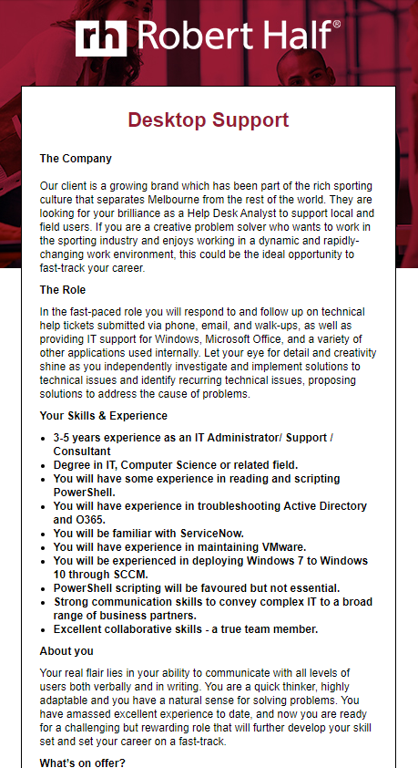

The position that would be ideal for me is